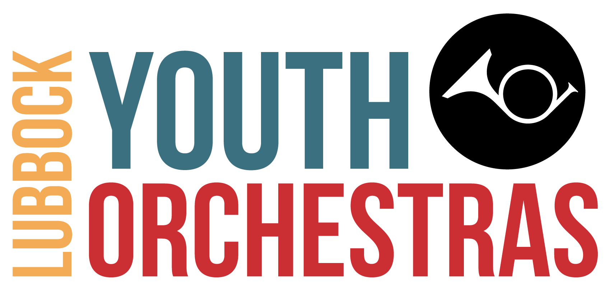
Lubbock Youth Orchestras

APPLICATION FOR NEED-BASED SCHOLARSHIP
2023-2024 Season

- You must complete the Registration Form before submitting this application. Your application will not be considered unless the student is registered. The Registration Form may be found on the LYO website, youthorchestrasoflubbock.org.
- The information in this application will be held in the strictest of confidence.
- Since funds are limited, this application is needed to ensure that the funds are allocated based on need.
- This form is to be filled out by the parent/guardian responsible for the support of the student.
- You may scan the documents and send them to education@lubbocksymphony.org.
- This application form and required documents below needs to be submitted by July 21st, 2023. Late submissions will not be considered.
- Submitting this form does not guarantee eligibility or that the applicant will receive the scholarship.
- Program participation is contingent upon having all tuition paid in full by the start of the LYO 2023-2024 season. You will be notified of the committee’s decision by July 31st, 2023.

Please select one of the following:
- We are applying for a Partial Scholarship
- We are applying for a Full Scholarship

Check List of Required Materials:
- Completed Scholarship Application Form
- Cover letter from a parent/guardian providing of summary of why the financial support is necessary and how the student will benefit by attending LYO
- Copy of the first page of both parents'/guardians' most recent tax return form.

- A recommendation letter (on page 2) must be from a person who has worked with the student and is qualified to tell of the student's musical skill and capability for the LYO program. The recommendation letter must be signed by the person making the recommendation. That individual may scan and email the letter to education@lubbocksymphony.org or mail the letter to Lubbock Youth Orchestras, 601 Avenue K, Lubbock, Texas 79401.

Student Name:
 | Address:
 | City, State, Zip:
 | Phone Number:
Parent/Guardian Name: |  |  | Email Address:
 | Address:
 | City, State, Zip:
 | Phone Number (Cell):
Name of Another Parent/Guardian:
 | Address:
 | City, State, Zip:
 | Phone Number (Cell):
Number of Family Members in the LYO Program:
Private Teacher's Name and Telephone
Number:
Adjusted Gross Income from the Most  Recent Tax Return: |  | $

Recommendation Form

Student's Name:
- Please answer the following questions in as much detail as possible
- Send the completed form by emailing to education@lubbocksymphony.org or mail to Lubbock Youth Orchestras, 601 Avenue K, Lubbock, Texas 79401
- This form should be submitted by July 21st, 2023
In what capacity do you know the student?
At what level do you think the student is ready for participating in orchestral music?

How do you think the student will benefit by attending the LYO program?
Additional Comments:
Name:
Phone Number: Email Address:
Date (MM/DD/YY): | Signature:

